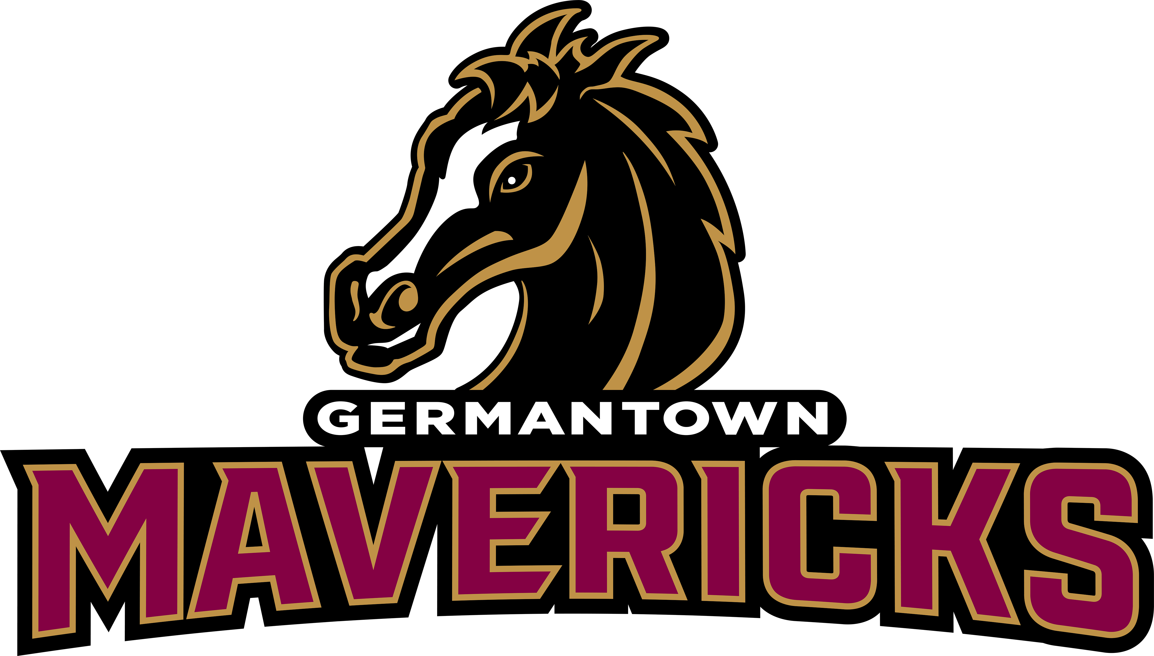
Business Name: (Please print clearly)

__________________________________________

Contact Name: __________________________________________

Contact Number: _________________________

Contact Email: _________________________________________

Form of Payment: (NO CASH)

_______ GoFan(Visit gofan.co) _____money order _____Check # ______Venmo @gomavsbooster

Ad Prices: _________ ¼ Page 4.25 x 5.5“(black and white)- $150
_________ ¼ Page 4.25 X 5.5” (color)- $190
_________1/2 Page 8.5 x 5.5” (black and white)- $200
_________1/2 Page 8.5 x 5.5” (color)- $375
_________ Full Page 8.5 x 11” (black and white)- $350
_________ Full Page 8.5 x 11” (color)- $750
_________ Inside Front Cover (color)- $850 (first come, first serve basis)
_________ Inside Back Cover (color)- $850 (first come, first serve basis)
_________ Back Cover (color)- $1000 (first come, first serve basis)

- Please email PRINT-READY AD and form to: ghsmavsmediaguide@gmail.com. Ads should be the exact dimension listed above but do not require bleeds. Covers do require bleeds.
- -Make checks payable to “MAVS” Booster Club
- If paying by check or money order, drop it off at the GHS front office in an envelope marked MEDIA GUIDE or mail it to MAVS Booster Club, 409 Calhoun Parkway, Madison, MS 39110.

ADS must be submitted and paid by JUNE 15!

*If you have any questions, please contact Nicole Shows via email at ghsmavsmediaguide@gmail.com

**Ad Salesperson: ________________________________________________________

